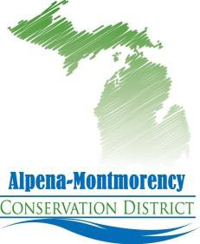

2022
Deer Habitat Improvement Program

Handbook and Scoring Details

Provided by:
Alpena-Montmorency Conservation District
and
Michigan Department of Natural Resource
Initiative Summary
Schedule for Deer Habitat Improvement Program Grants
Request for Proposals Begins November 1, 2021
Grant Application Must be Received by February 14, 2022
Review & Selection Process Completed-Awards Announced March 1, 2022
Project Period Begins Upon execution of Grant
Project Period Ends September 23, 2022

The Northern Lower Peninsula Deer Habitat Improvement Program (DHIP) is a small grant program designed to improve white-tailed deer (Odocoileus virginianus, hereafter deer) habitat on private lands to facilitate the increased harvest of deer. Program goals are to reduce the size of the local deer herd and thereby reduce the transmission of Bovine Tuberculosis (bTB) by drawing deer away from agricultural lands where they pose a disease transmission risk to livestock and cause damage to agricultural crops. Approved grant projects will emphasize habitat activities that make deer more vulnerable to hunting, help reduce crop damage and improve forest diversity..

Project Focus Area
This grant program will have a focus area within the following northern Lower Peninsula counties: Alcona, Alpena, Montmorency, Oscoda, and Presque Isle. These counties were selected because there is both Bovine Tuberculosis in the deer herd and a high incidence of crop damage by deer.

Initiative Goals and Expectations
The purpose of the DHIP is to develop a collaborative approach between the Michigan Department of Natural Resources and the Alpena-Montmorency Conservation District to manage deer habitat on private lands in the northern Lower Peninsula. Conservation District staff and/or Department of Natural Resources Wildlife staff must have access to the property to inspect the approved proposals. All projects must be technically feasible, have a reasonable budget and will score highest if they meet the following five objectives:

- increase deer availability to hunters on private land;
- produce and/or improve on-the-ground deer habitat in the project focus area while attempting to not exacerbate negative effects to native forest ecosystems;
- increase partnerships between private landowners, agricultural producers Conservation Districts, Michigan Department of Natural Resources, and other partners;
- reduce transmission of Bovine Tuberculosis, reduce agricultural damage, and reduce forest regeneration damage;
- increase the harvest of deer, especially antlerless deer and;
- increase the testing of deer for Bovine Tuberculosis.

DHIP funding
DHIP is funded from the Deer Range Improvement Program (DRIP) Fund. DRIP funds come from $1.50 that is collected from every deer hunting license sold in Michigan. The intent of the DRIP fund is to provide financial support to improve deer habitat statewide. A total of $50,000 will be available for grants and program delivery in 2022.

The required partner cost-share for approved projects must be at least 25% of the total project cost. This can include labor or in-kind services. Grant applications will be accepted for a minimum funding amount of $500 and a maximum of $2,500. Total requested funding for a specific project may be reduced on a case-by-case basis so that the overall goals of the program are met across as many properties as possible. Other minor requested changes to proposals may also be discussed on a case-by-case basis.

Grant Application Process and Requirements
This grant can be applied for every year by the same applicant. Previous year project accomplishments will determine eligibility for the current year. Failure to complete all grant requirements will jeopardize future funding. See Appendix A for a breakdown of scoring categories and available points.

PLAN grant participants CANNOT receive DHIP funding for the same fiscal year.

Proposal Criteria and Selection Process

Examples of desired habitat improvement projects include but are not limited to: food plots, wildlife opening creation or maintenance; conifer plantings, and tree planting to increase hard or soft mast. Planting of trees or shrubs should include adequate protection (fencing) where appropriate. It is encouraged to consider planting perennials when creating or maintaining food plots.

Specific Activities That Will NOT Be Considered

Specific activities that will not be considered are:
- plantings of exotic or invasive species, such as miscanthis, autumn olive, glossy buckthorn, tartarian honeysuckle, etc.
- commercial timber sale preparation
- construction of ponds or other water sources, access roads/trails, or hunting blinds
- planting of trees for the specific purposes of aesthetics or wind breaks
- Proposals that:
  - increase undesired habitat fragmentation
  - increase wildlife disease transmission potential
  - have human safety implications
  - are contrary to deer management goals
  - will have known direct adverse impacts on state or federally listed threatened and endangered species

Guidance for Specific Activities:

- Food Plots
Food plots provide supplemental food for deer and can aid hunters in harvesting deer. Food plots may also draw deer away from agricultural crops and help reduce crop damage. Food plot establishments should be based on soil type and amendments (fertilizer, lime) made based on current soil test recommendations.

- Planting of invasive species, such as miscanthus, is not fundable;
- Perennial plots are preferred, but not required;
- When possible, the use former log landings, gas well sites, roadways/skid trails/two tracks or old fields for creation of food plots is preferred;

2. Conifer Plantings
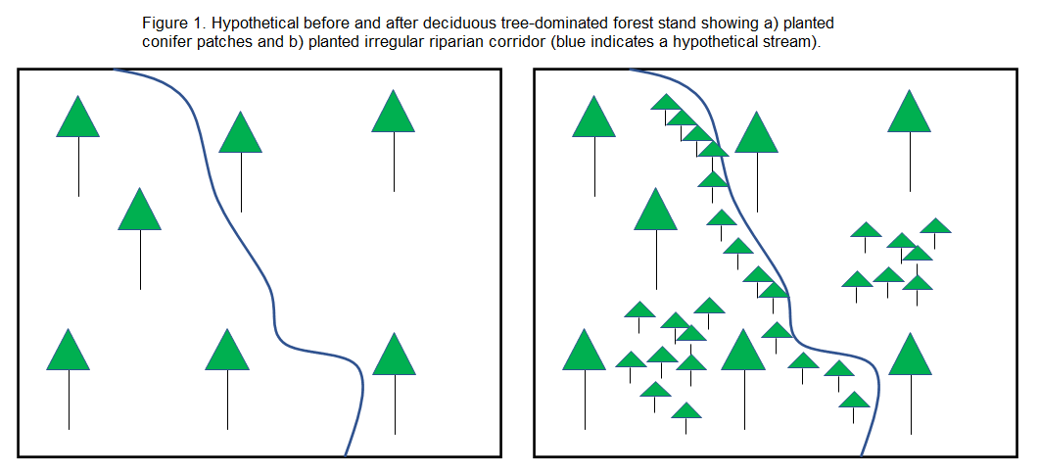
When properly planned and planted, conifers can increase hunting opportunities for deer by providing bedding, thermal cover, escape, and travel cover. This cover can then be hunted to achieve the overall program mission.

Note: preference will be given to conifer patches over corridors.

- Eligible native conifers include eastern white pine, white spruce, red pine, jack pine, balsam fir, and black spruce;
- Non-native conifers (Norway spruce, blue spruce, Douglas fir, etc.) are not eligible;
- Select conifers baed on natural landscape patterns, soil types, soil moisture and sunlight (sun, shade, partial). This information is usually found in a land (forest or wildlife) management plan and landowners are encouraged to review their plans and/or contact their plan writer for input. Landowners may also contact the Conservation District for more information;
- No plantings in regular, geometric shapes or rows (i.e., no plantations or similar);
- Minimum 25 seedlings per patch within forest stands;
- Minimum 50 seedlings in unforested areas. Avoid planting in dense grass or mark planted seedlings with a pin flag so that they can be found later;
- Riparian or other corridors should be planted with multiple native conifers in multiple and irregular layers;
- Plantings must be at least 450 feet from home or buildings. Funding not available for plantings adjacent to driveway, farm lane, or road;
- Plantings to occur at non-linear spacings of at most 7’x7’ spacing to produce dense cover;

- Hard and Soft Mast Plantings
- Eligible hard mast trees: oak (burr, swamp white, red, white) or hazelnut (American, beaked)
- Eligible soft mast trees: apple, pear, crabapple (except Siberian)
- Non-native or hybrid trees, such as hybrid chestnut are not eligible;
- Review land (forest) management plan and/or consult plan writer or Conservation District to match plantings with soil types found on property;
- All plantings of mast bearing trees or shrubs will require some form of protection (e.g., tree tube or fencing or other);
- Fruit bearing trees should include protection from rodents and deer (e.g., tree guard that wraps around bottom 12” of planting);
- Plantings that include both conifer patches/corridors and hard/soft mast trees are encouraged.

Land Management Plan: only a land management plan written by a professional forester or wildlife biologist will receive full points in this category. Examples of acceptable land management plans include a Forest Stewardship Plan, NRCS Conservation or CAP Plan, Qualified Forest Program plan, American Tree Farm System, or a plan written by a professional wildlife biologist. An example checklist for a land management plan can be found here: https://www.michigan.gov/documents/mdard/Forest_Management_Plan_Checklist_690788_7.pdf

Proximity: Project properties that are adjacent to or in close proximity (1 mile) to cattle farms or active agriculture, or that have an active forest or wildlife management plan will receive additional points towards the final score.

Required practices for grant funding:
- Harvest of deer, especially antlerless deer, is a required component of this program and is crucial to decreasing the prevalence of Bovine Tuberculosis in the deer herd. It is important to get deer TB tested at a local DNR check station: www.mi.gov/DeerCheck

- All applicants are required to monitor deer activity by filling out a Deer Camp Survey. The Deer Camp Survey can help the applicant imperfectly track deer population trends. A copy of the completed survey will be collected by the Conservation District. These data will be compiled after the deer season and turned into the DNR.

- Applicants are also required to complete the online Deer Harvest Survey at the end of their hunting season, see: www.mi.gov/Deer. The survey can be completed online and is also mailed to random hunters across the state; data are used by the DNR to estimate hunter participation, deer harvest, and hunter effort.

Budget: reasonable costs for your project must be used. Inflated prices on materials (including trees, fencing, seed, fertilizer) and labor will not be accepted. All budgets are up for review by selection committee and changes may be required before accepting your project proposal.

DHIP Partnership:
- New applicants will receive full partnership points and will be required to fulfill all required partnership goals of this grant.
- Prior applicants’ projects from previous years will be reviewed to determine eligibility. Applicants who had not met all reporting, testing and match requirements the previous year will be ineligible for funding.

Scoring:
Immediately following the application deadline, a selection committee of Conservation District staff and DNR wildlife staff will evaluate proposed projects. All complete applications meeting the eligibility requirements will be reviewed. The selection and project scoring process are designed to be objective, standardized, transparent, and treat all applicants the same.

The selection committee may approve, reject, or request modifications to projects. Selection committee decisions will be final. Notification of project acceptance will be made by March 1, 2022. Notification of unfunded projects will be made shortly thereafter. Failure to meet project obligations or noncompliance as spelled out in the project contractual agreement will result in project termination and ineligibility for applying the following year.

A work agreement, including project description, will be signed by successful applicants and the release of grant funds will occur after the project has been successfully completed and a final site inspection has been held.

Implementation
For all approved projects, the applicant or their representative will be required to periodically report to the designated Conservation District staff on the project status, expenditures to date, future habitat management actions to be completed, and estimated timeline for completion throughout the implementation process (final deadline is September 23, 2022). Once habitat management actions are done, all receipts including labor and equipment costs must be submitted to the Conservation District. Once everything is received CD staff will do a site visit to verify that the project was completed.

Appendix A-Grant Scoring Criteria

The Conservation District staff and DNR wildlife staff will review all grant applications and determine their eligibility. For eligible project proposals, the application is scored using the following criteria which reflect the goals and objectives of the program.

Scoring Criteria | Maximum Score
DHIP Partnership | 5
Food Plots | 5
Tree Plantings | 5
Land Management Plan | 5
Proximity to Cattle Farm or Active Agricultural Property | 5
Total Maximum Score | 25

REQUIRED CONTENT FOR ALL APPLICATIONS:

- Project location map
- Documentation of proximity to cattle farm or agricultural land (e.g., air photo)
- Plat book location (can be provided by Conservation District)
- Proof of land management plan

Scoring Breakdown
Each criterion is broken down below and each one indicates what is necessary to score each point.
DHIP Partnership
(Maximum of 5 Points Available)
New applicant to DHIP | 5
Previous year applicant and followed all agreement requirements for documentation and deer testing | 3
Food Plots
(Maximum of 5 points Available)
New food plot establishment, at least 2 acres in size. | 5
Maintenance of existing food plots. | 3
No food plot | 0
Tree Plantings
(Maximum of 5 Points Available)
Plant a mix of a minimum of 10 hard mast AND 10 soft mast trees | 5
Plant a minimum of 10 hard mast OR 10 soft mast trees | 3
Plant a conifer patch or corridor following required guidelines | 2
No tree planting | 0
Land Management Plan
(Maximum of 5 Points Available)
Current land management | 5
No professional management plan | 0
Proximity to Active Agricultural Property, Especially Cattle Farms
(Maximum of 5 Points Available)
Project property is within 1 mile of a cattle farm | 5
Project property is within 1 mile of active agriculture | 3
Further than 1 mile of either cattle farm or active agriculture | 0

